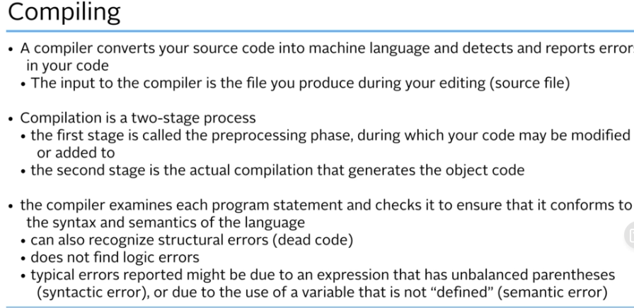

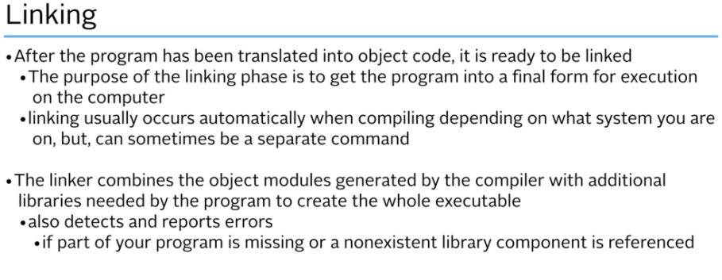

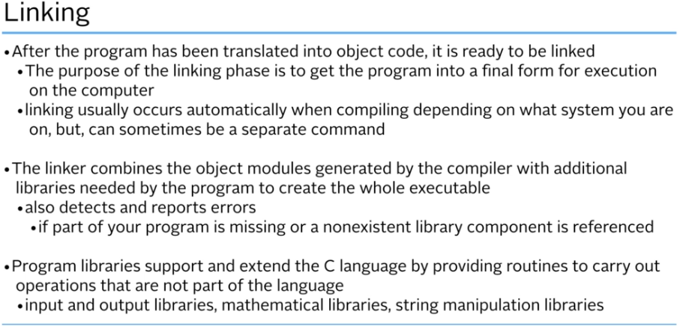

Error will happen if missing a .o

You want many source files, easier to go through

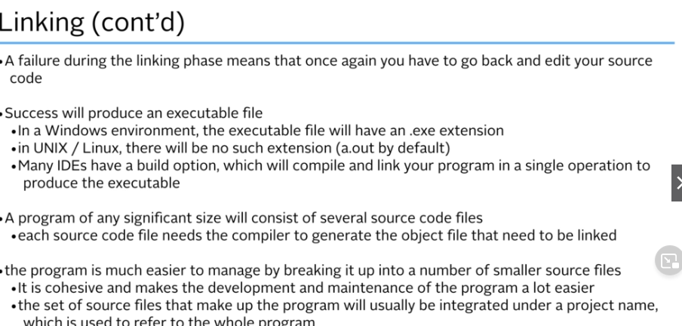

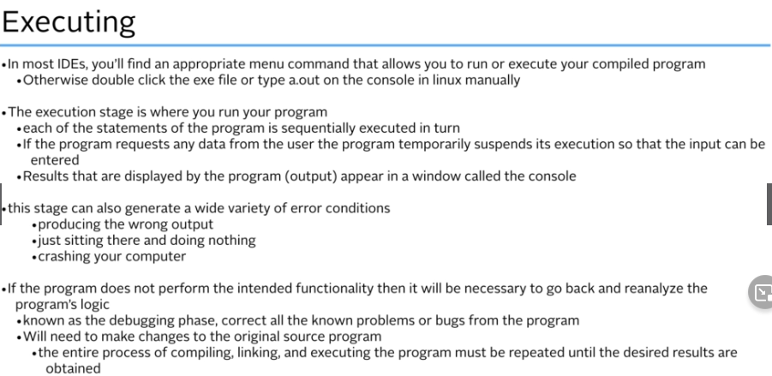

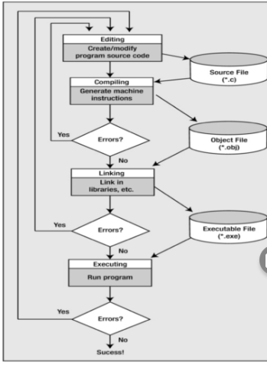

Program basics

Comments

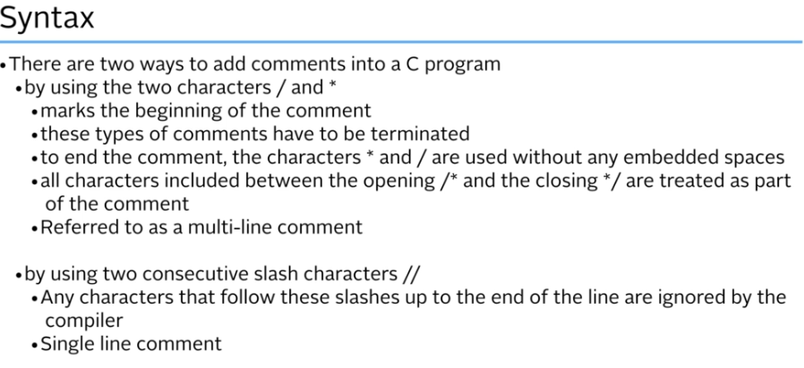

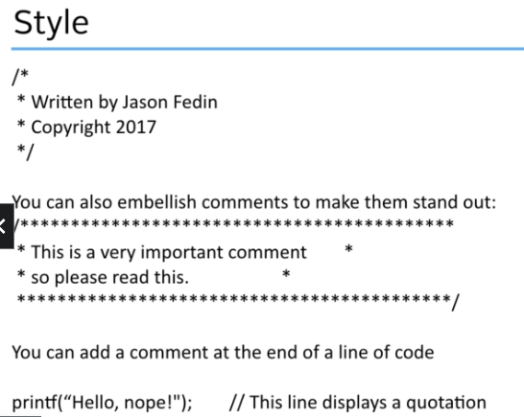

The preprocessor

Header files

All make header files in lowercase

Use #includ <jason> for standard lib

Use #include “Jason” if home made

** use #ifnotdef and #define to protect against multiple inclusions of a header file

Executable code normally goes into a source code file, not a header file

**Header file :** .h is list of definitions and functions, no flow.

**Object File :**

**Video28**

**Scanf**

Printf / scanf are called control strings

Followed by a list of arguments

Stdin is the keyboard

Scanf reads from stdin

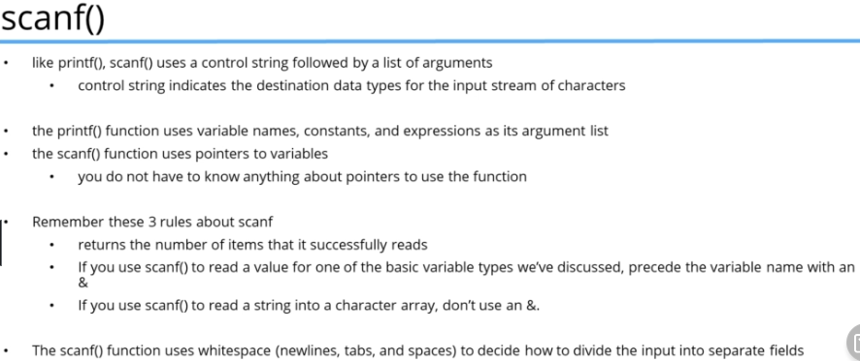

If variable is a string don’t use &

*** printf converts ints, floating point number characters and C strings to text to be displayed on the screen

Scanf converts input text to the data type

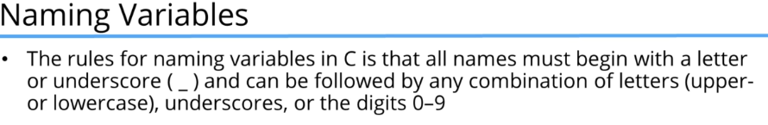

Everything is primitive data. No objects

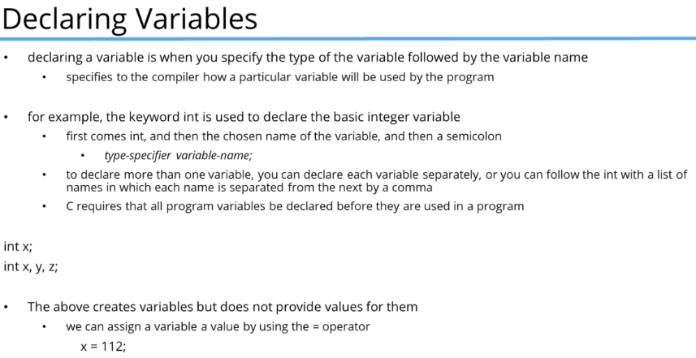

# Basic Data Types

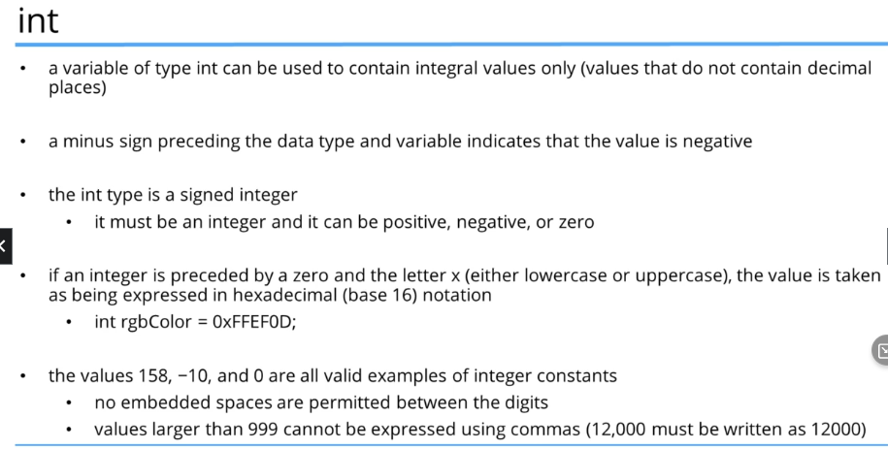

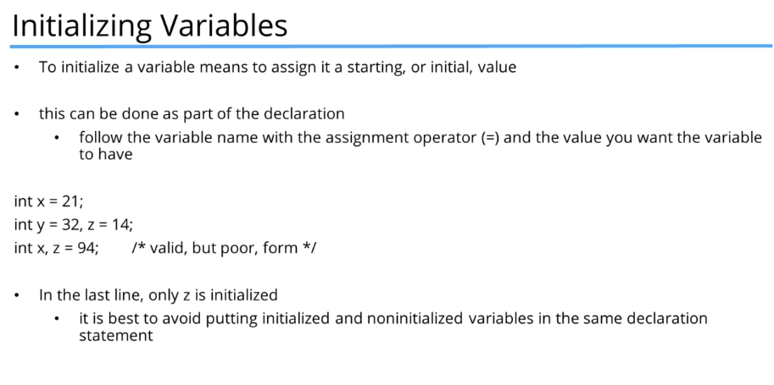

# Enums and chars

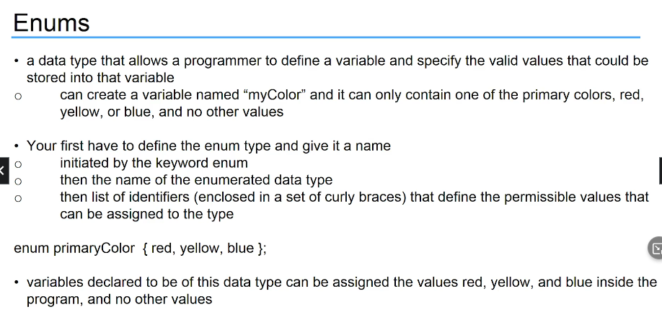

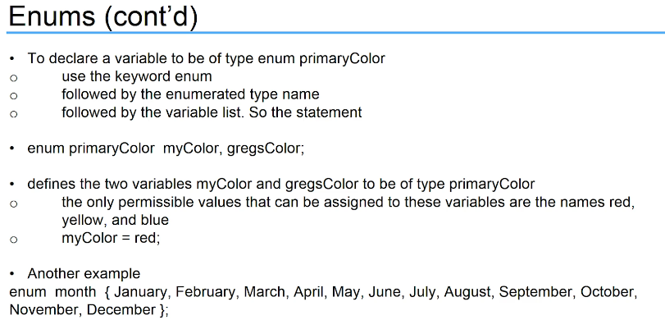

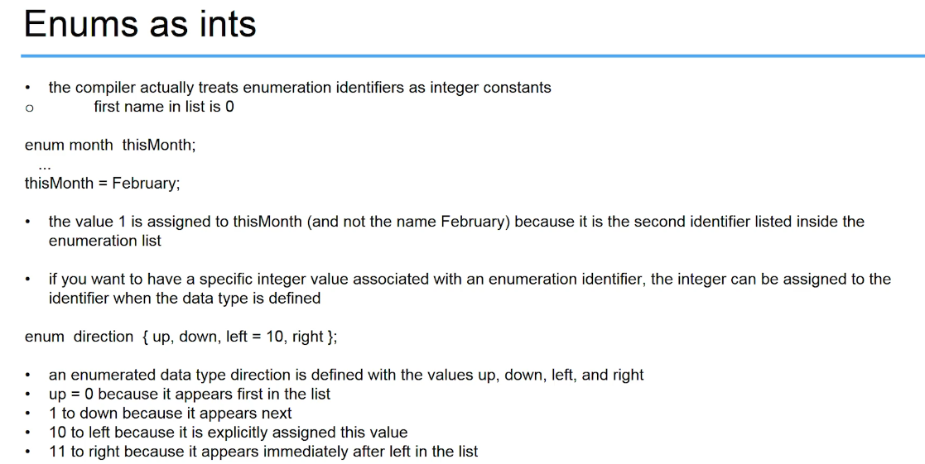

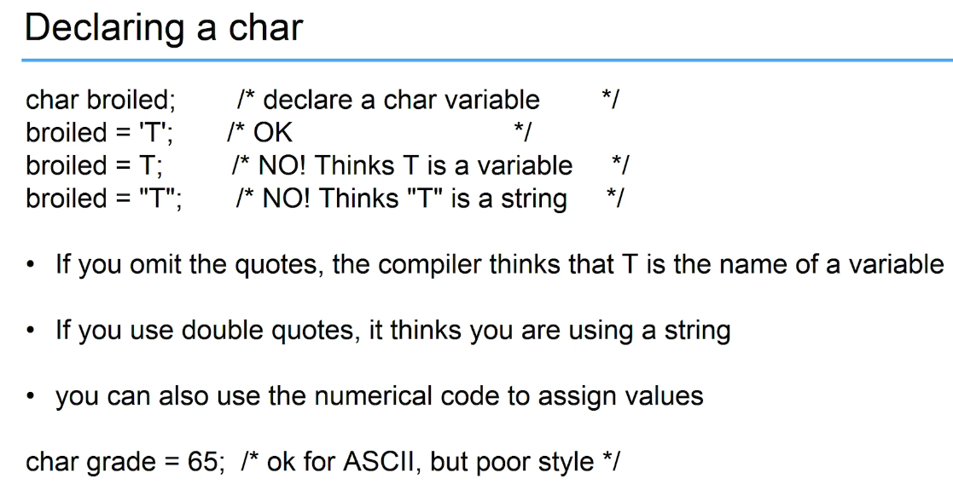

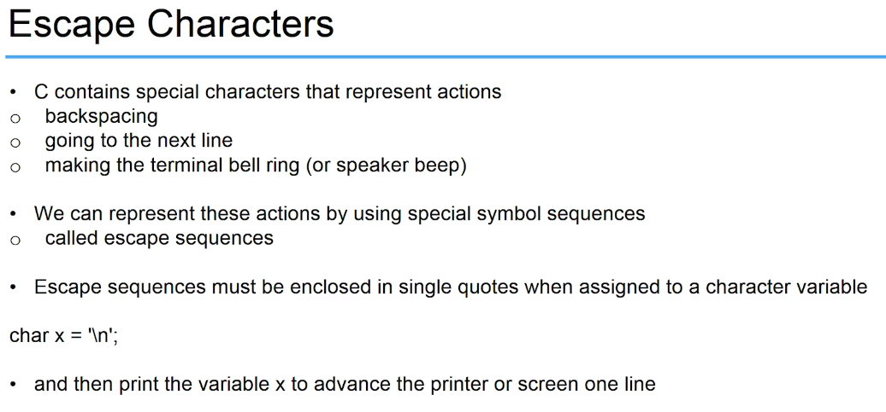

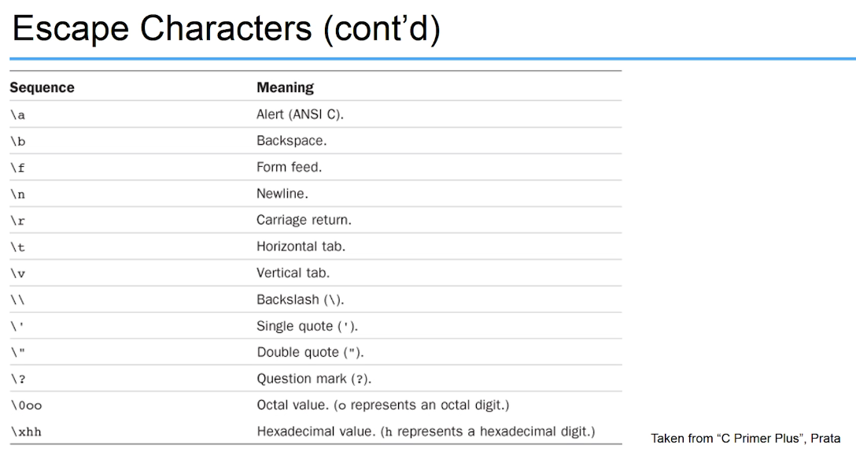

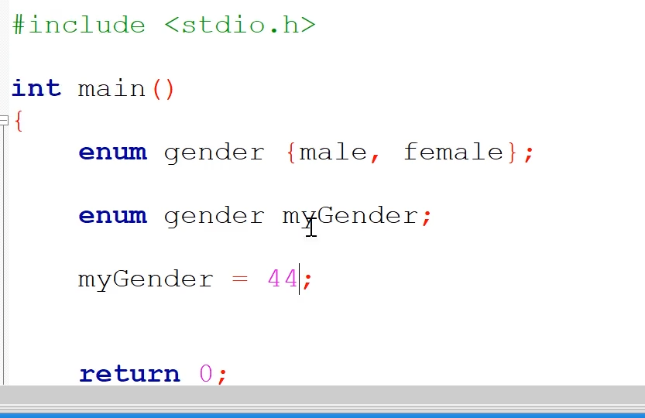

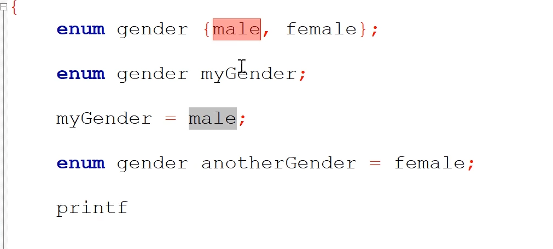

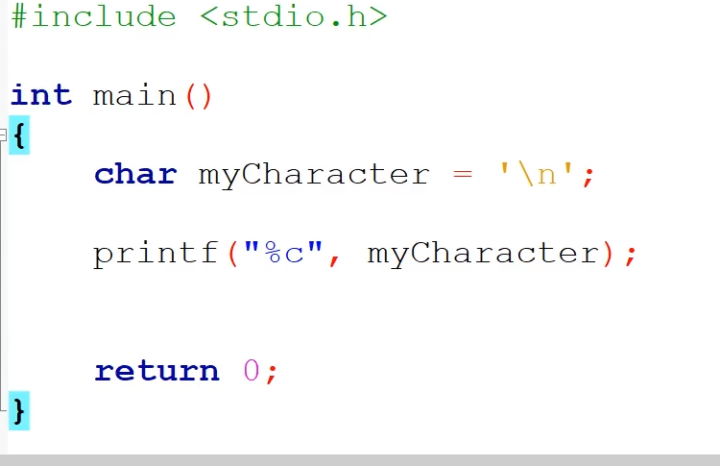

# Format Specifiers

Can be ued to convert data

Function id

Parathensis, coma, qoutations. Function arguments are the data you are passing to the functions

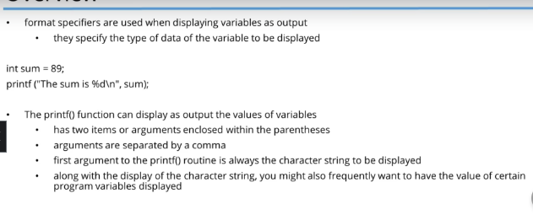

%d is mapped to variable sum, /n is line % is format specifier d= integer “single letter option”

Behind % is the type of data we want to print

The data that we are going to print is after the comma

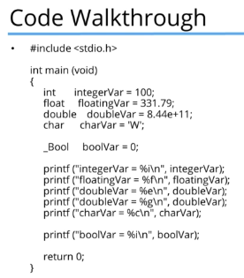

Bool prints an intger cause it is

-Print more than one variable on the same line

You can put as many format specifiers between the double quotes and those are going to be mapped

To whats ever after the comma.

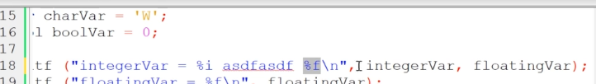

Can use advanced methods per type of specifier

Width specifier

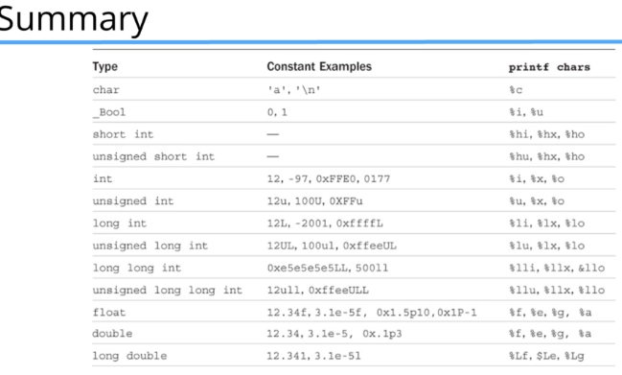

# Command Line Arguments

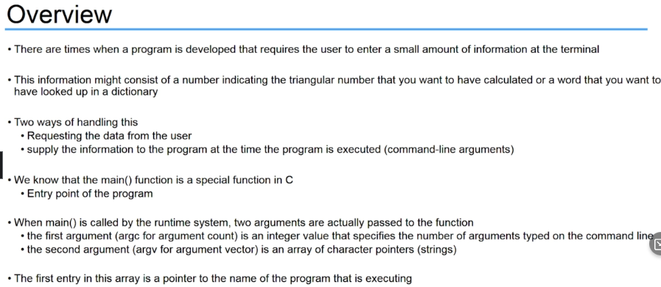

# Arrays

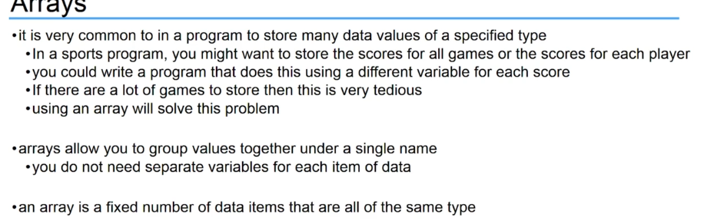

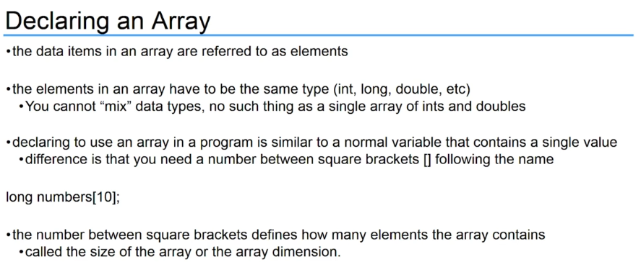

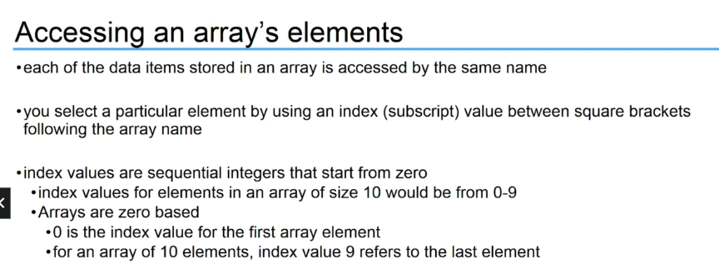

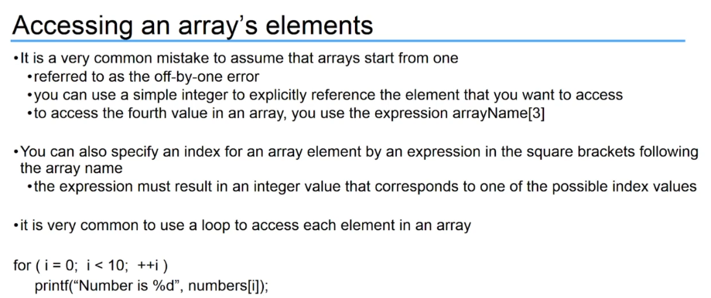

This iterates through #9 and prints a new “I” variable.

This is a loop pulling a variable.

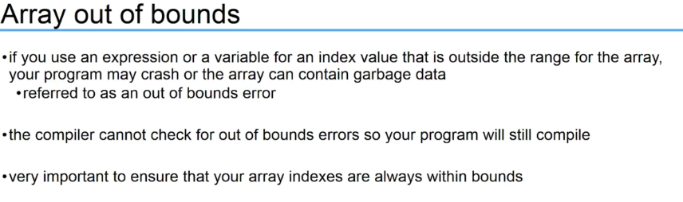

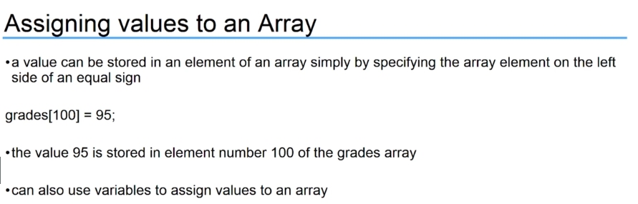

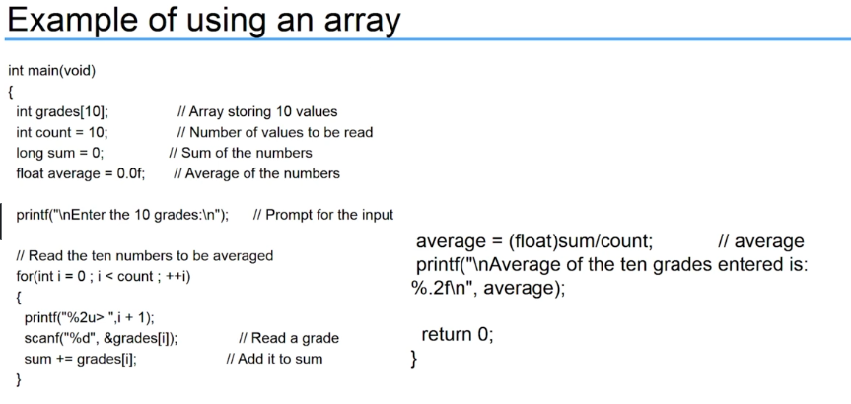

Long sym is we are adding the values as we go along

In scan f we are assigning data to the subscript &grades to [i]

## Iniialization

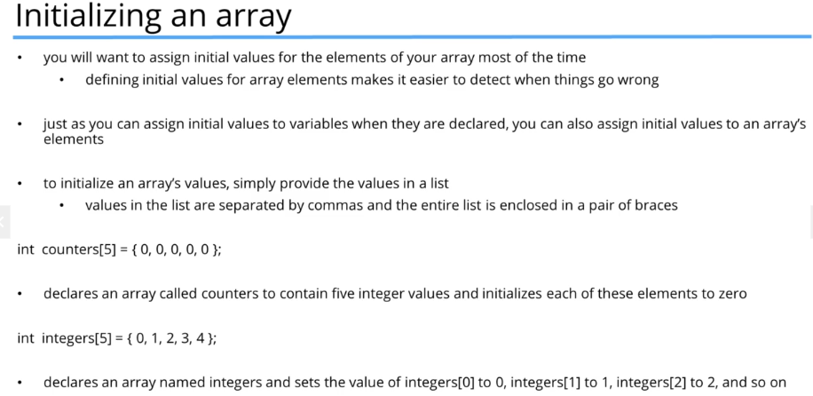

Goes through array list and prints data

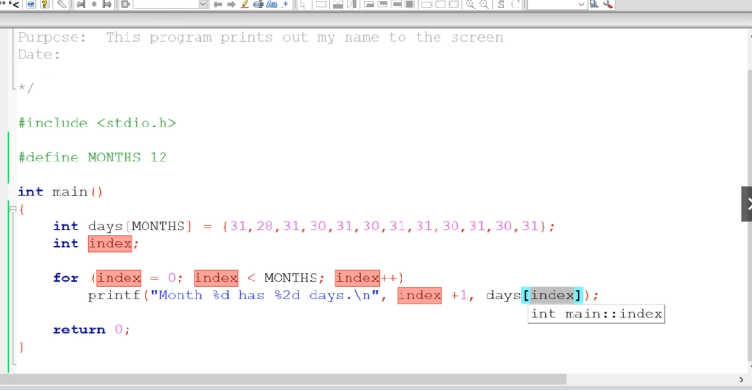

# Functions

Declare functions at top

Void add;

## Return

is very clear that you are exiting a function.

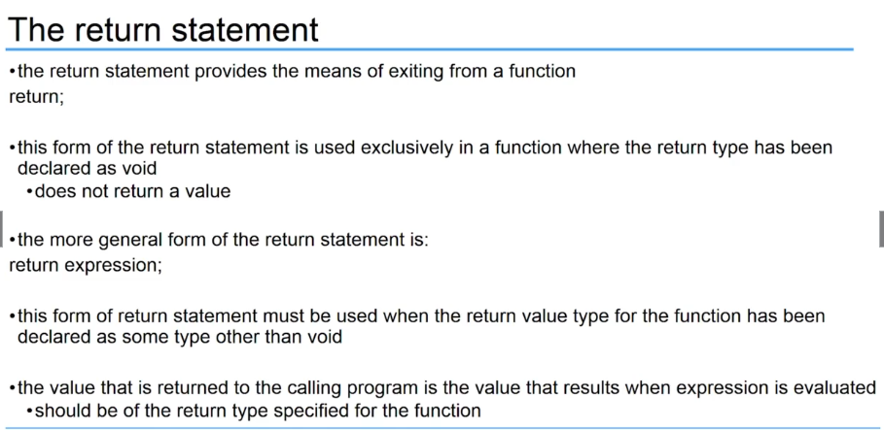

If you have a function returning something make sure that it is of that type

Returna has to be in if statement or loop, cause your jumping out

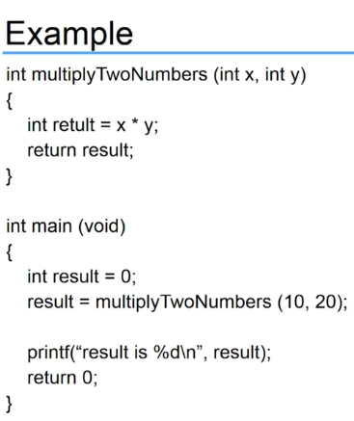

# Control Flow

## Switch

Switch is like “ if “, but its going to be looking at an expression or a variable

The case values are are comparing the values against the expressions in the switch

The expression is compared to all the values

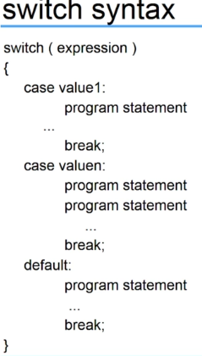

Expression is compared to all the values and if it equates to any of the values, you execute the code inside that value

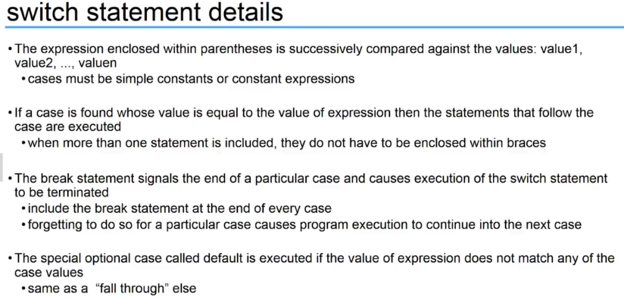

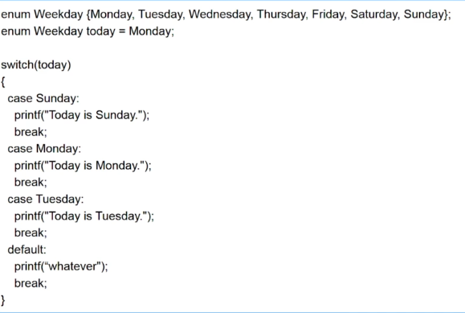

# Strings

Double quotes u have strings

Sing le quotes you have characters

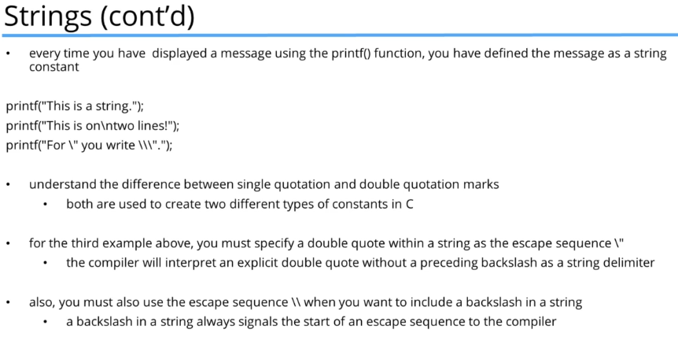

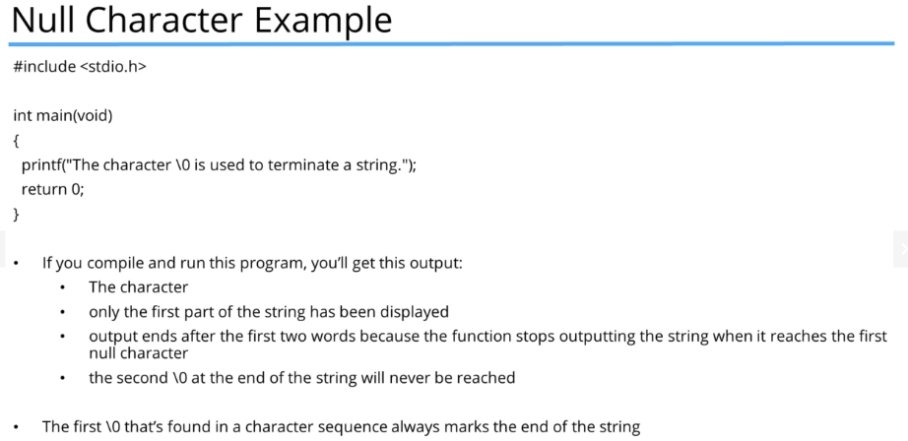

# Debugging

Focus on the first error may lead to other errors

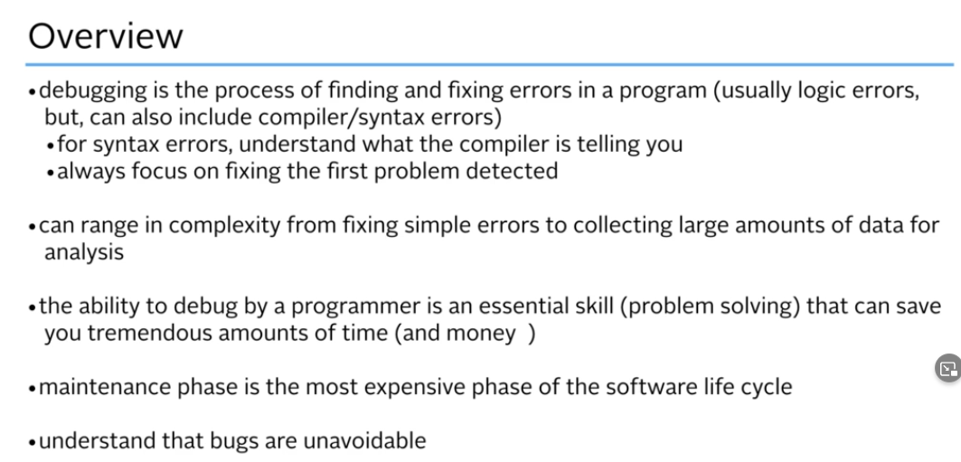

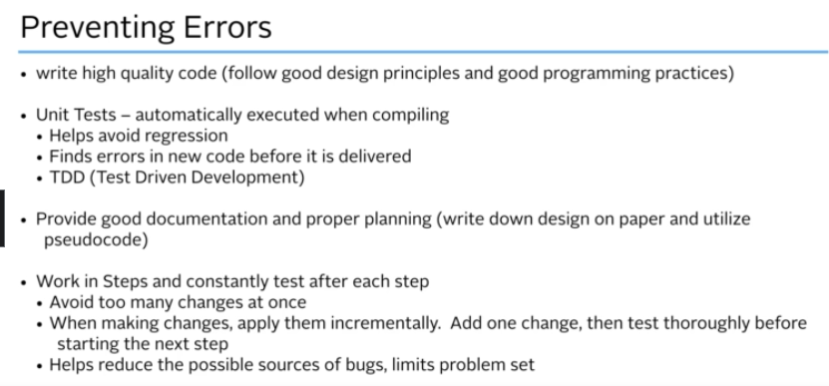

## Call Stack

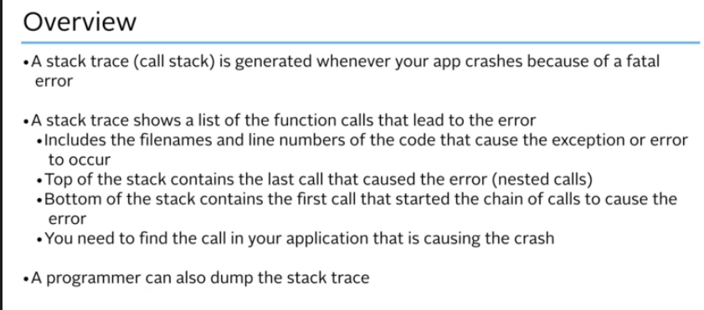

Break point so you can look at it line by line or look at the values of variables

Look at step into out of and next instruction

Add windows

Call stack

Can see functions and data passed.

Can take you to different source files

watches

see function args.

# Common C mistakes

Semicolon

== or =

Omitting prototype declarations -put at top



Compiler will error notifying linking problem

Confusing a character constant and a character string

Text = ‘a’;

Text = “a”;

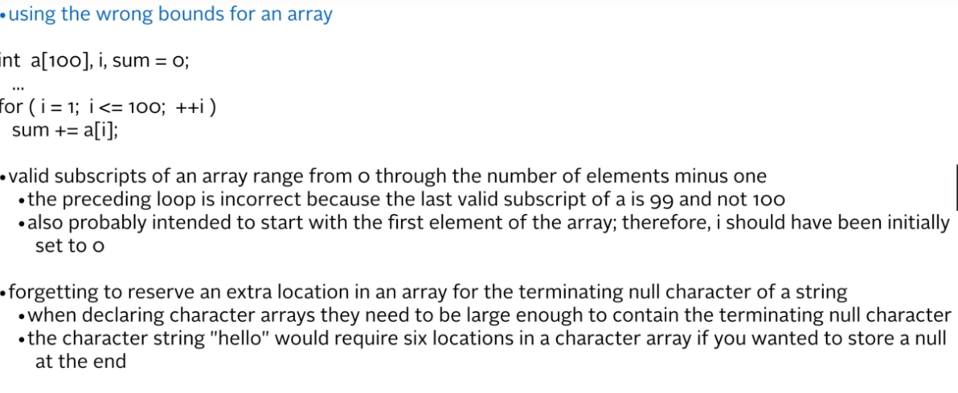

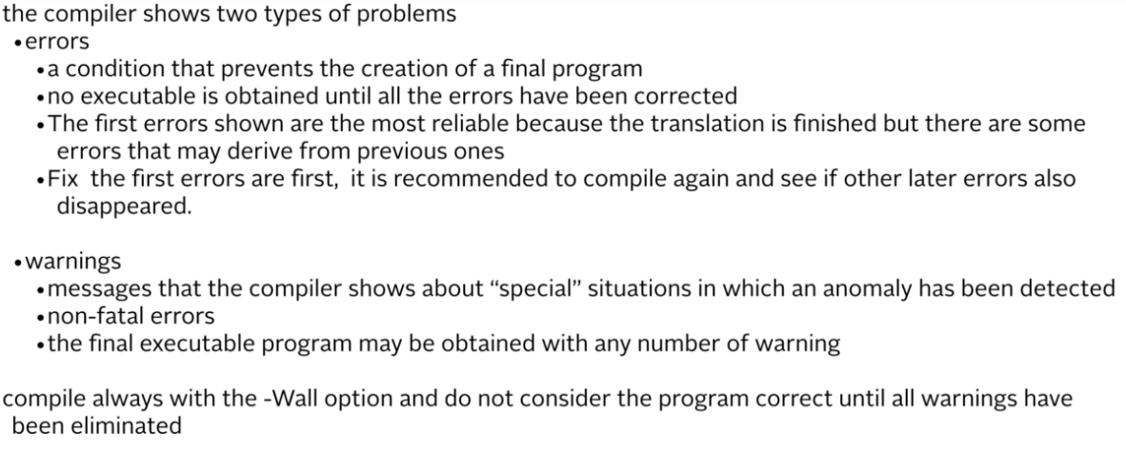

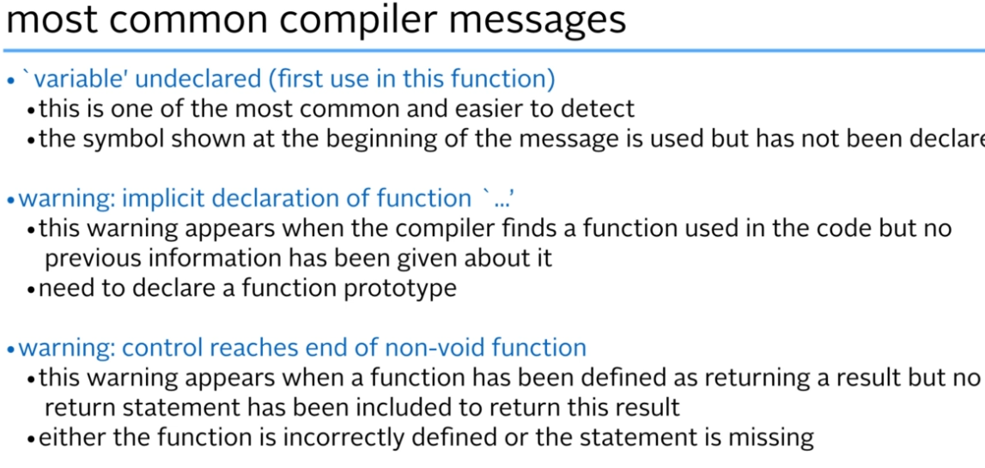

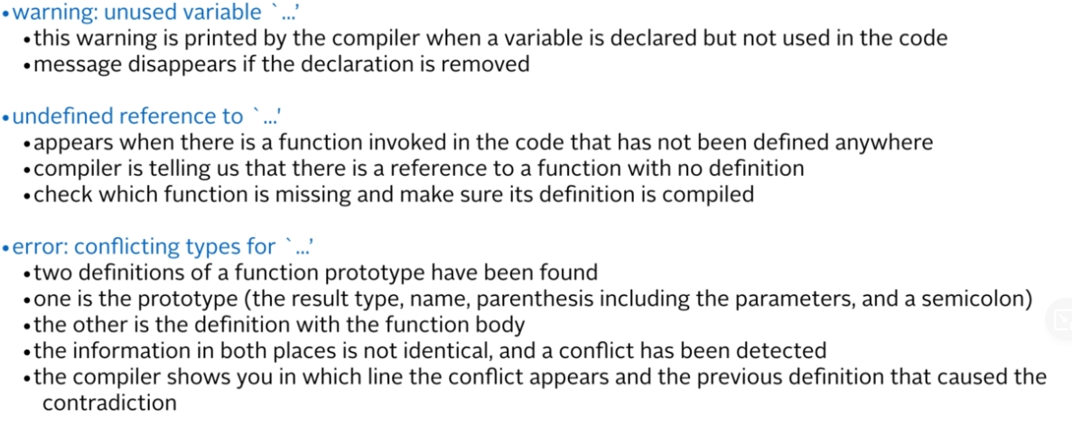

# Pointers

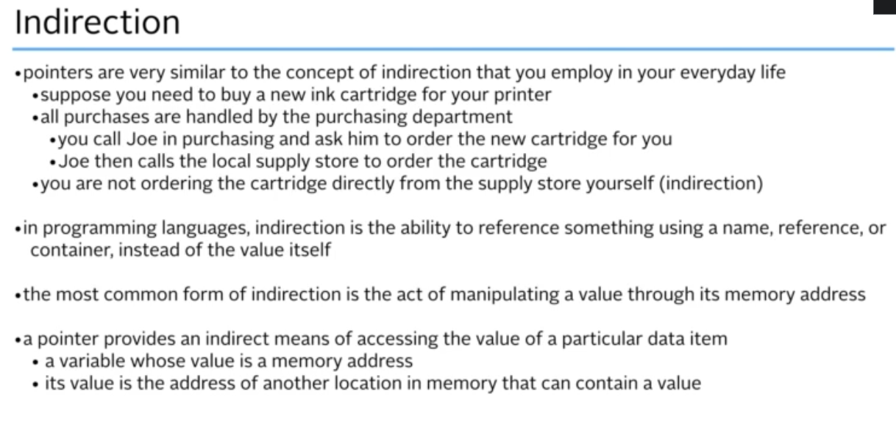

In c you have a variable that explicitly represents an address

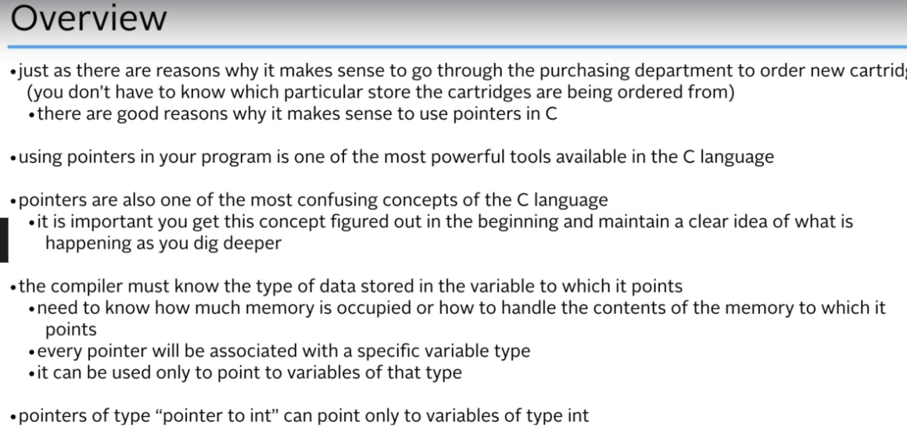

Pointer - A variable that has value of an address. That address may contain a value somewhere in mem

A pointer can only store addresses and you can write code to access that address /variable

Int *pnumber is pointer

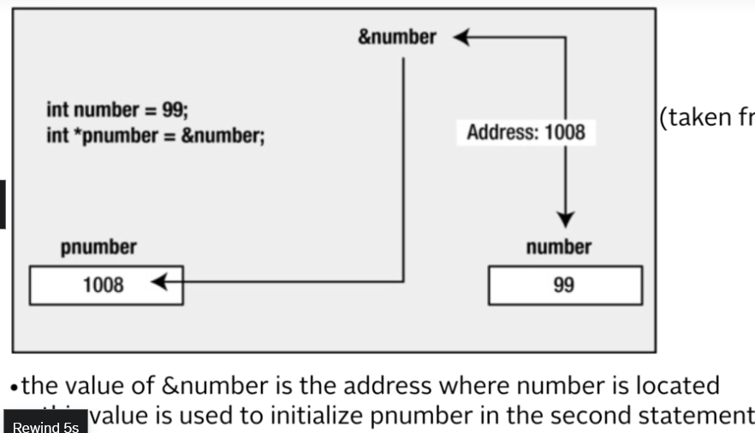

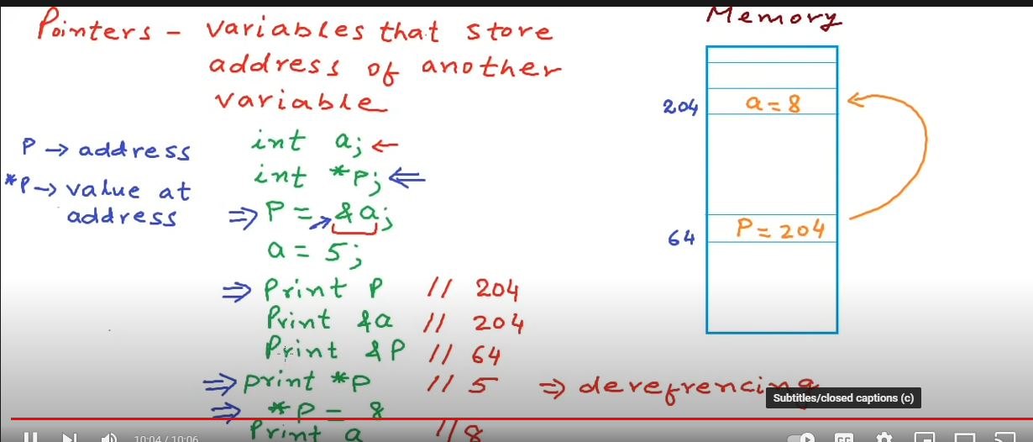

P =address

*p = value at address p

P = &a = address of a (operating at that address)

# Structures

# File I/O

# Standard C Lib